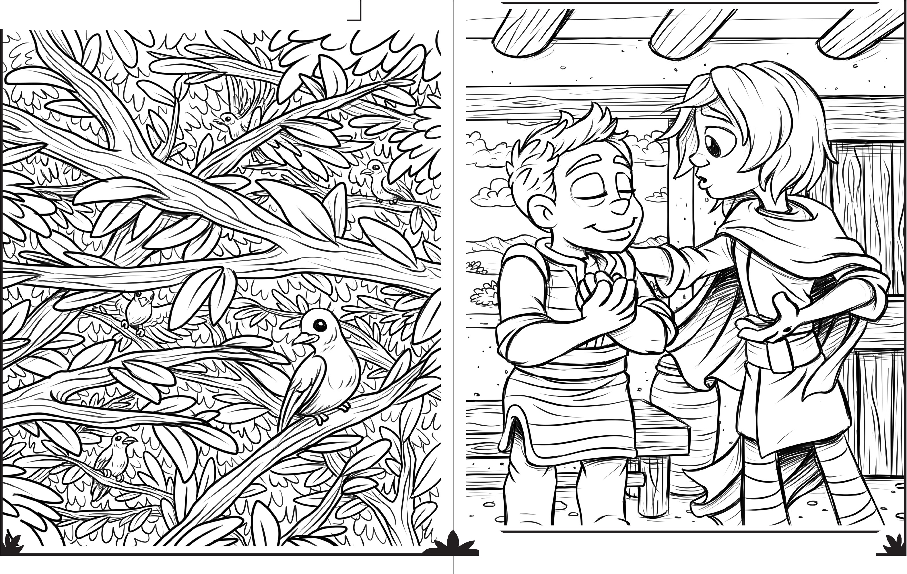
JESUS THEN BREATHED ON THEM AND SAID, "RECEIVE THE HOLY SPIRIT."

In the picture below are 5 doves:

Can you find them all?

THe

CREATOR'S

TOYCH€ST
AGES 3-6 MAY 31, 2020 JOHN 20:19-23

WWW.CREATORSTOYCHEST.COM ILLUSTRATED BY JAMES KOEtllG-WWW.FREELAtlCEFRIDGE.COM

ON THE NIGHT AFTER JESUS ROSE FROM THE DEAD, THE DISCIPLES WERE TOGETHER WITH THE DOORS LOCKED
WHEN JESUS CAME AND STOOD AMONG THEM. WHAT DID HE SAY?
JESUS WMTS US TO TELL OTHERS ABOUT HIM. JESUS TOLD THE DISCIPLES:" "AS THE FATHER HAS SENT ME, I AM SENDING YOU."

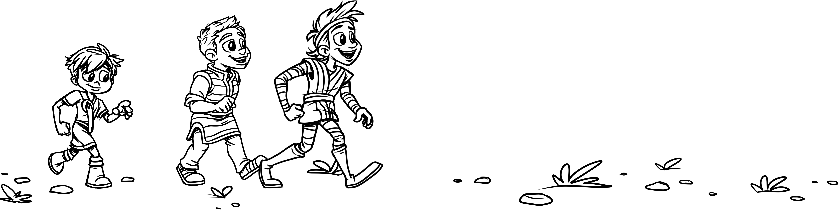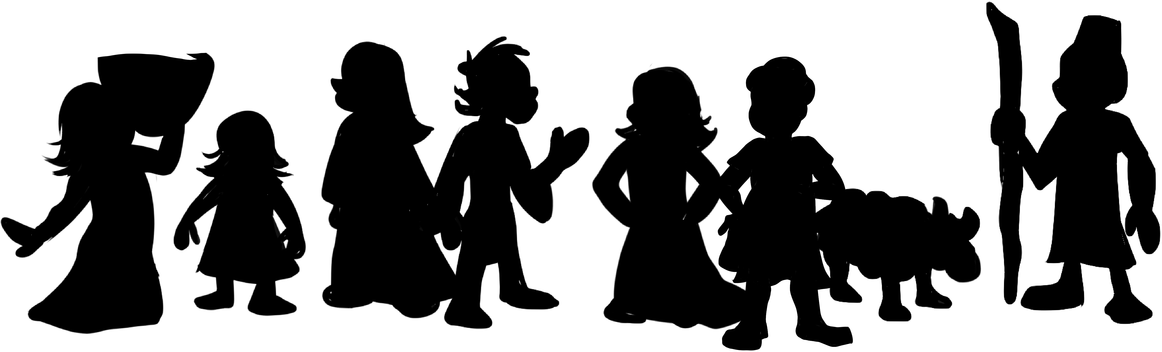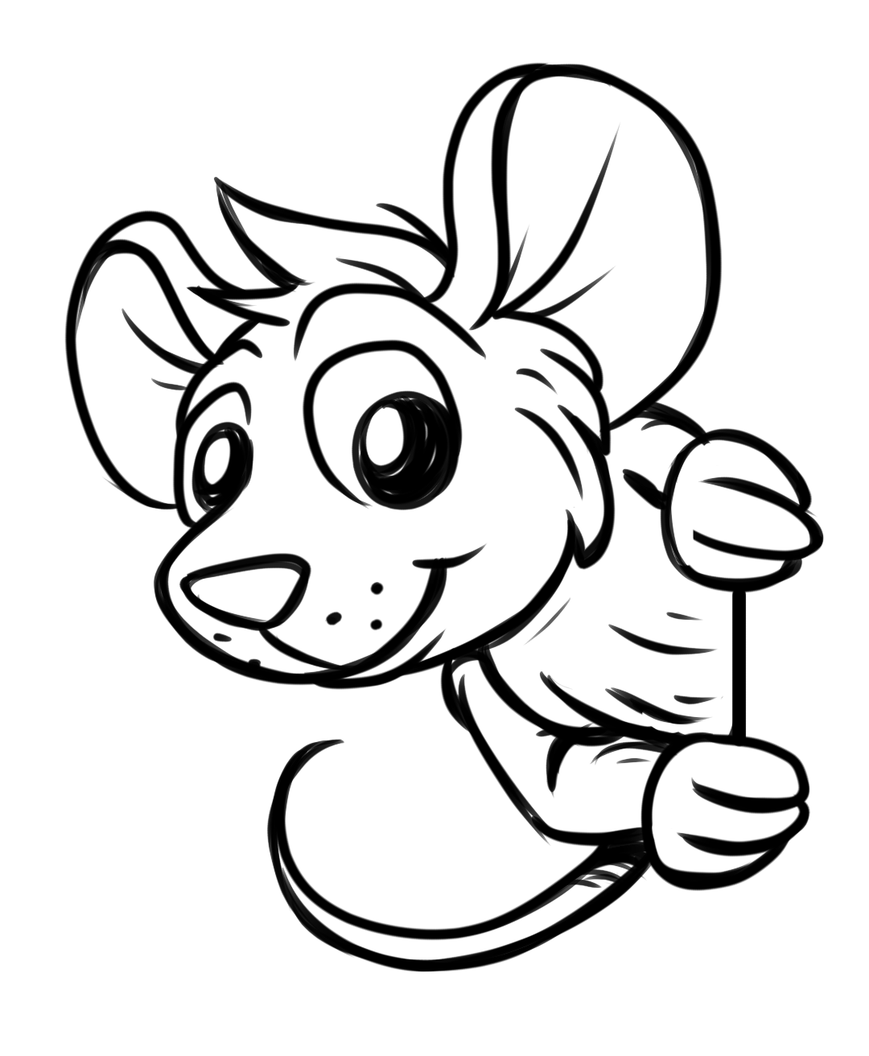
Cross out every letter that appears 4 or more times. Circle the letters that are left and write them in order on the lines below.

P D X E F N A
Help the disciples get to the people.
D | X | C | F | E | X | N
B | N | X | E | X | W | I
D | T | H | F | Y | D | F
O | F | N | X | U | D | N

"

"

l.·no,{ 4//M aq aoead,, :1aMSU\f]

JESUS THEN BREATHED ON THEM AND SAID "RECEIVE THE HOL y SPIRIT." '

In the picture below are 6 doves:

Can you find them all?

AGES 7-12

THe

CREATOR'S

TOYCH€ST

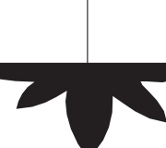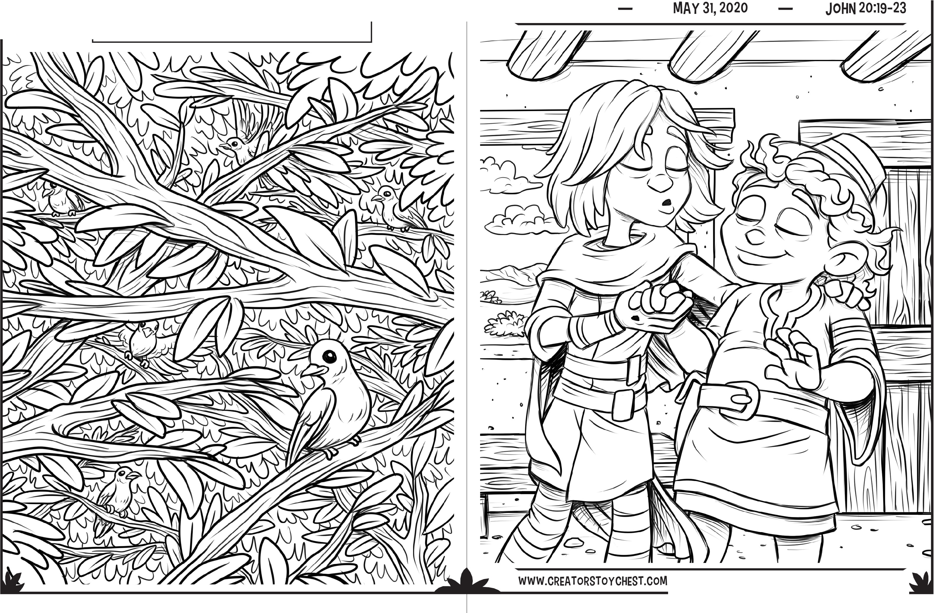

ILLUSTRATED BY JAMES KOEtllG-WWW.FREELAtlCEFRIDGE.COM

ON THE NIGHT AFTER JESUS ROSE FROM THE DEAD
THE DISCIPLES WERE TOGETHER WITH THE DOORS LOCKED. SUDDENLY JESUS CAME AND STOOD AMONG THEM. WHAT DID HE SAY?
Follow the arrows to find the correct letter for each puzzle.
For example, F i+ i+ • = C
Find F in the box below. From there move two letters to the right, and one letter down. Your answer is C.
WHAT ELSE DID JESUS SAY To THE DISCIPLES?

Write the letter that is missing in each box on the lines above.

II be with II
1 2 3 4 5 6 7 8
1.N••• =_
3.M••···
"A ------
s
B C D F
F G I
J
p
Q
R
T

u
V

w

A A
u
V
s
R
Q
R
T
u
E F G
C D F G
G
I
J
K
D E G H
0
p

2.Q•·••=-
4.W••••==-_
E
y

Q
s

-------- ----' A
s
u
V
R
K L N 0
H J K L
C D F G
L N 0
p
K L NI 0
B C D F
R
T
u
V
Q
T

5.R -t-t••=-
X 0 z
6.D•••-t=_
7.L•••=-

8.G••••=-

------------
Q
R
T
u
D F G H
K L NI 0
A B C E
F G H J
NI
0
p
Q
E F H I

------ "

s
NI N
p
Q
V
w
X
z
T
V

w

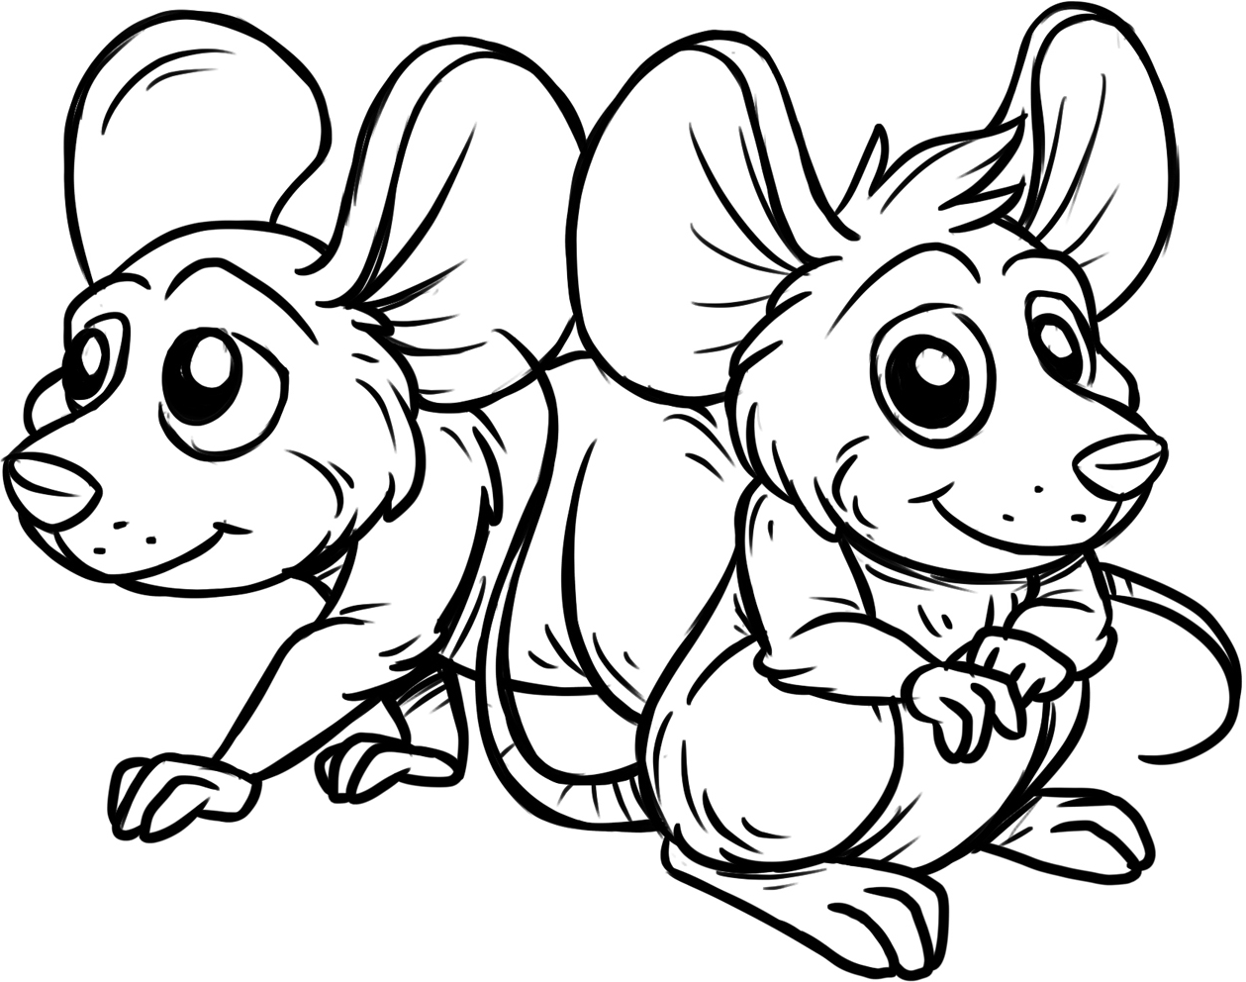l. ·no,( 41/M aq aoead ,, :1aMsuvJ

{,,·no lf 6u1puas we J 'a w 1uas seq JBL/Je::J a41 sv,, :JaMsuv}

